**ANNOTATE IMAGES**

**INSTALL MICROSOFT’S VISUAL OBJECT TAGGING TOOL**

|  |  |
| --- | --- |
| Date | 17 November 2022 |
| Team ID | PNT2022TMID34120 |
| Project Name | AI- Based Localization and classification of skin disease with Erythema |

**STEP:1**

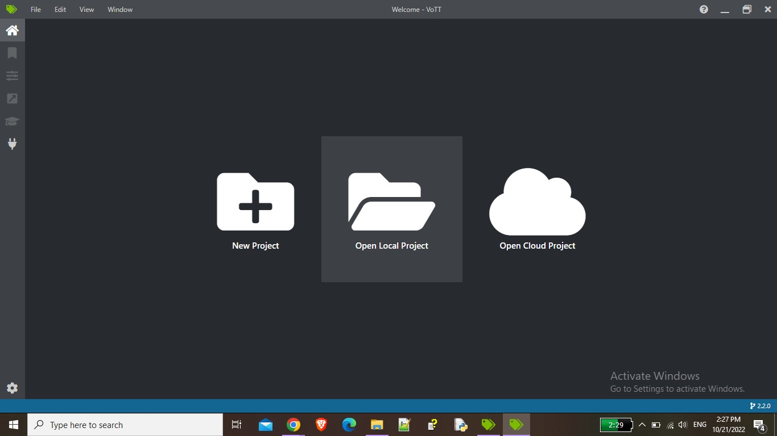

**STEP:2**